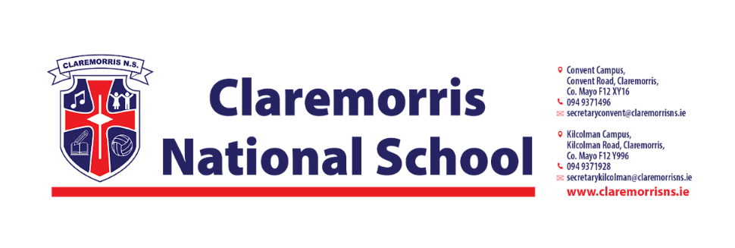

**Senior Infants Stationery List**

**2025/2026**

All school books, workbooks and copies will be funded by the Department of Education and bought by the school.

**Children should bring the following items to school on 28th August:**

1 x Plastic A4 Mesh Folder – homework folder (with zip)

1x Rubber/Eraser

2 x Pritt Stick 43g

2 x Black Whiteboard Markers

2 x Crayola Twistables **(1 for school & 1 for home)**

4 x 15A Blue Ormond Project Copy Book – Top blank, bottom wide ruled (40pages)

**Please do not label these items.**

**Senior Infants do not need a pencil case in school.**

***In line with our Green Schools Policy, each child must have a reusable bottle and lunchbox. Tinfoil is not permitted for wrapping lunches.***