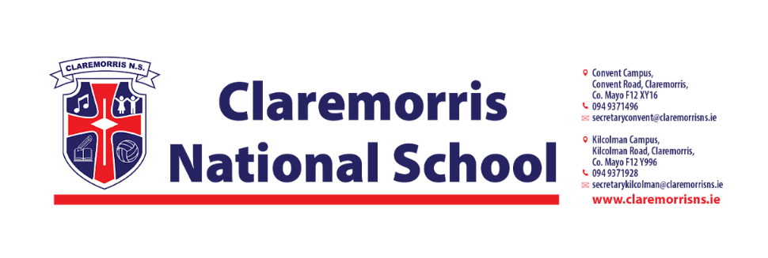

**4th Class Stationery List**

**2025/2026**

All school books and workbooks will be funded by the Department of Education and bought by the school.

**Children should bring the following items to school on 28th August:**

1 x A4 Polly Pocket Display Book (60 Pages)

1 x A3 Plastic zipped Mesh Wallet (must be **A3** in size)

2 x A4 Plastic zipped Mesh Wallet (must be **A4** in size)

3 x HB Pencils

3 x Red Pen (Bic)

3 x Blue Pen (Bic) (Individual pens only please)

1 x Small Scissors

1 x Pencil Sharpener

1 x Eraser

1 x 30cm Ruler

2 x Pritt Stick

1 x Small Sellotape

4mm Knitting needles and large ball of wool (Pick any colour)

1 pack of Colouring Pencils/Twistables

1 pack of 4 Whiteboard Markers

1 x Calculator

2 x 88 page Sums Copy

2 x 88 page Writing Copies

3 x A4 Manuscript Copies with Durable **Plastic** Cover (**Not** Hardbacks)

1 x Earphones/Headphones (Keep from 3rd Class)

***In line with our Green Schools Policy, each child must have a reusable bottle and***

***lunchbox. Tinfoil is not permitted for wrapping lunches.***