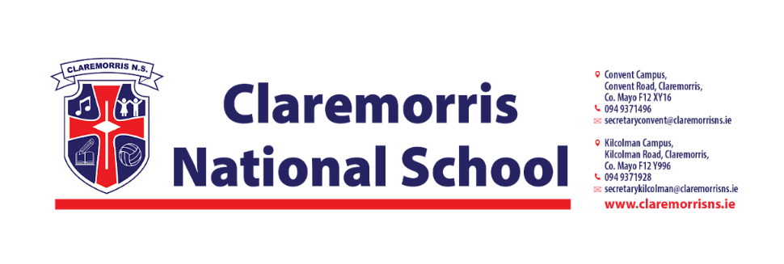

**Junior Infants Stationery List**

**2025/2026**

All school books and workbooks will be funded by the Department of Education & Youth and bought by the school.

**Children should bring the following items to school on 28th August 2025:**

1 x Plastic A4 Mesh Folder – homework folder (with zip)

2 x Pritt Stick 43g

2 x **Crayola** Twistables **(1 for school and 1 for home)**

1 x **Ormond** Junior Sum Copy (32 pages)

2 x **Ormond** Practice Book Blank (32 pages)

2 x Black Whiteboard markers

**Junior Infants do not need a pencil case in school.**

**In line with our Green Schools Policy, each child must have a reusable bottle and lunchbox.**

**Tinfoil is not permitted for wrapping lunches.**